Flood relief campaign at Rangeli municipality, Morang District
Map of Rangeli municipality
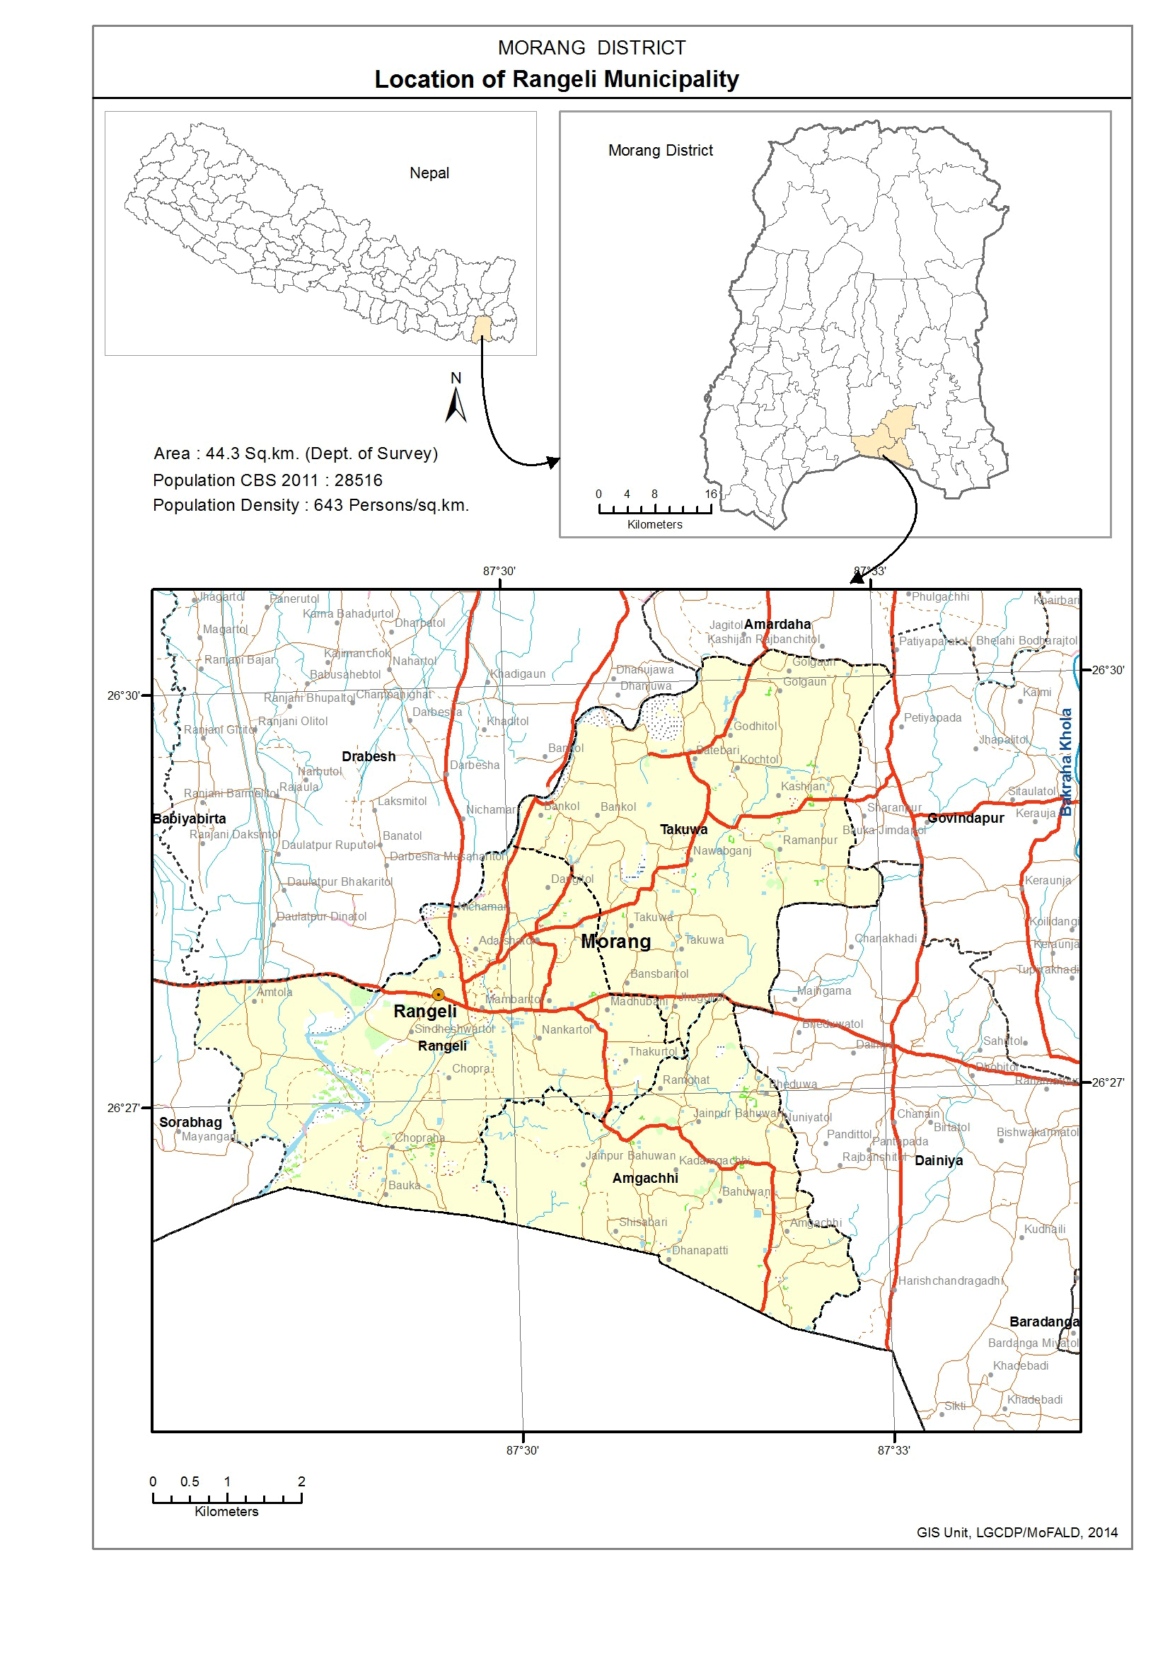

Date of the visit: 3rd September 2017 – 7th September 2017
Name of the place: Rangeli Muncipality, Morang District
Purpose of the visit: Distribution of basic commodities including wheat flour, blanket, Sarbottam Lito,Tarpaulin,Oral Rehydration Solution,Water Purifier ,soap, bucket, jug, etc and general medical camp
ANMF team members/volunteers: Shaswat Acharya, Bikrant Rana
Name of the persons met and discussions done: Chief District Officer, President of Bar association of Nepal , Chief of Rangeli municipality, President of all wards of Rangeli municipality
Discussions: According to discussions done with the above mentioned government officials, 1047 flood affected families were in dire need of relief materials (out of 6119 families) of Rangeli municipality. Furthermore they requested us to replace some of the relief materials with blankets because winter is nearing and it would be more beneficial to the flood affected families during the winter.
Activities done:
- ANMF team members and volunteers coordinated and assisted Ask foundation team members so as to distribute the relief materials to 1047 families of Rangeli municipality, who were highly affected by the flood. Also, the team conducted basic medical camp while distributing the relief materials.
List of relief materials:
- Blanket – 1 piece
- Wheat flour – 10 kg
- Bucket and Mug – 1 piece
- Soap- 1 piece
- ORS
- Water purifier
- Sarvatam pitho

Recommendation:
- It would have been more fruitful if a medical camp with specialist (for example ENT, Endocrinologist, Gynecologist etc) were involved.
- Awareness program is required in order to provide general health education.
- We should make sure to provide exact information to the village regarding the relief activity being conducted and to whom relief materials are being distributed (such as highly affected family or marginalized people or whole village)
- The plan and schedule of the distribution of relief materials should be informed earlier to the government officials and the local volunteers who are suppose to assess in the program.

Challenges:
- Effective assessment of the highly flood affected families and areas
- Participation with the local people so as to distribute the relief materials
- Fatigued volunteers
- Coordination with the local government
- Conducting a formal program with the government officials are involved (we think it is unnecessary)
- Time constraint
- Effective mobilization of the volunteers
- Managing transportation volunteers as well as relief materials
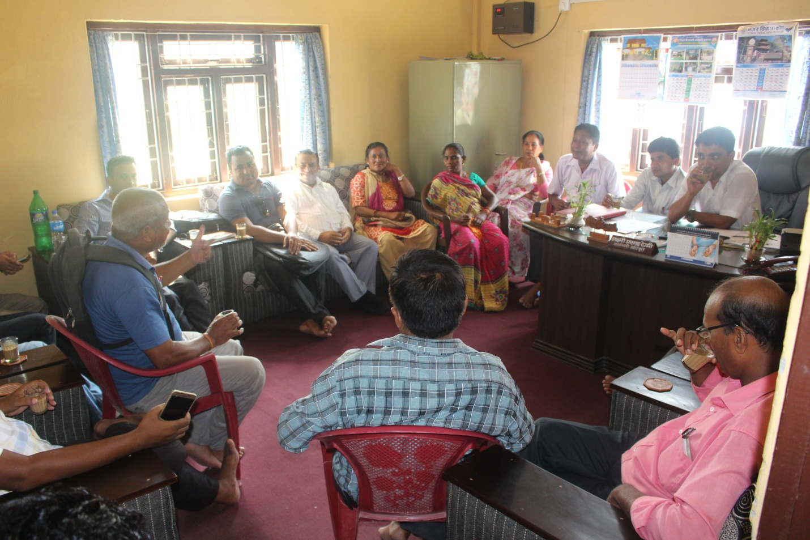
Meeting with the chief of Rangeli municipality along with the ward representatives

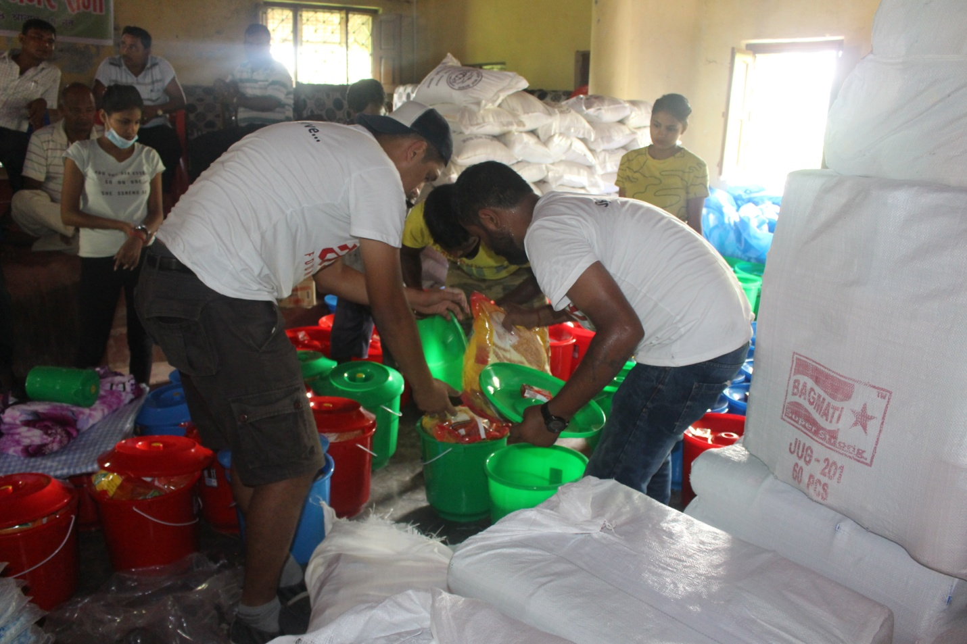
Team members and volunteers arranging the relief materials
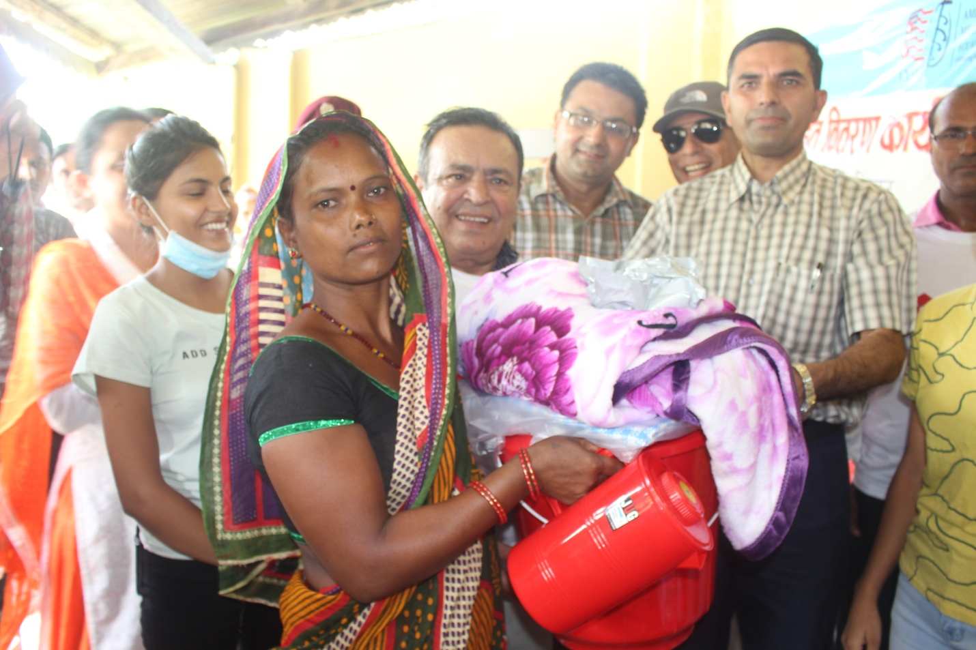
Chief District Officer distributing the relief materials

