
Mar 01 ₂₀₁₆


Joint Winter Blanket Drive (ANMF, Youth Thinkers’ Society, Sahayeta.org)

Table of Contents

About ANMF-Sahayeta-YTS Blanket Drive 3
VAT Receipt…………………………………………………………………………………………......4
Thank you Letter 5
Some picture 6

2.Joint Winter Blanket Drive (ANMF, YTS, Sahayeta.org)

About ANMF-YTS-Sahayeta Blanket Drive

On Saturday April 25, 2015, Nepal was hit by a magnitude-7.8 quake near the capital of Kathmandu flattening homes, buildings and temples, causing widespread damage across the region, killing more than 8,000 people and injuring many others. The quake was the strongest in the region in more than 80 years. Almost a year and passed, and yet Political turmoil along with the unofficial blockade has made it difficult for the victims to receive much needed aid.

On Jan 15th, 2016, ANMF joined hands with Sahayeta.org and Youth Thinkers Society (YTS) to help distribute 1360 high quality blankets to residents of Budhakhani(210), Sitkha(450) and Shreechaur(700) of Kavrepalanchowk, Ramechhap and Okhlandhunga district respectively. The residents are from diverse community and are still living in tents and makeshift shelters. Freezing temperatures and scarcity of basic needs such as electricity, gas and reliable shelters has made it very difficult for them to survive and many have already fallen sick. According to the survey done by the local YTS volunteers, they barely have any money to eat, let alone buy reliable blankets.

7138 Shelter Creek Lane, San Bruno, CA 94066 / www.sahayeta.org / info@sahayeta.org

VAT Receipt

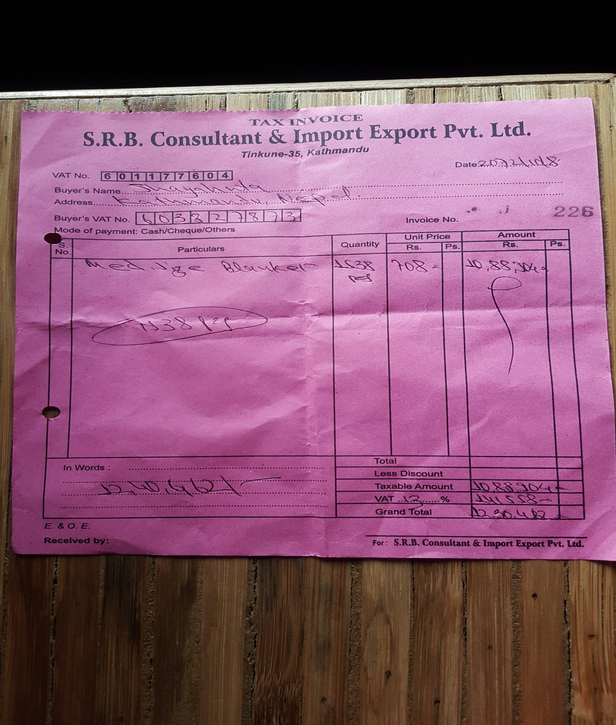

4. Joint Winter Blanket Drive (ANMF, YTS, Sahayeta.org)

Thank You Letter

Receipt of Charitable Donation

Date: Mar 01, 2016

Dear ANMF,

Thank you for your generous contribution of $10,000.00 to Youth Thinkers’ Society for our Winter Blanket Drive relief effort. Your support is greatly appreciated. 100% of the proceeds went towards blanket distribution effort for earthquake affected victims suffering in cold region of Nepal.

Sincerely,

Nisha Thapa
President
Sahayeta.org

Chewan Rai
President
Youth Thinkers’ Society

We thank you for your generous support! Please visit www.sahayeta.org to see how your donation is making a difference.

5. Joint Winter Blanket Drive (ANMF, YTS, Sahayeta.org)
Some Pictures
